Lab 14. 555 Timer

1. **Calculate the resistance of R2 and complete the connections**

**Parts:**

1. C1: 10μF Electrolytic Capacitor
2. C2: 0.1μF Disc Capacitor (103)
3. IC1: 555 Timer IC (name is shown on the IC)
4. L1: Red LED
5. L2: Green LED
6. R1: 680KΩ Resistor (blue, grey, yellow)
7. R2: choose as required
8. R3, R4: 1KΩ Resistor (brown, black, red)

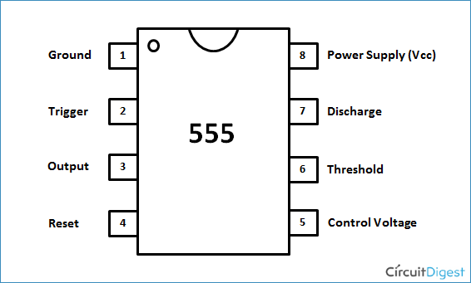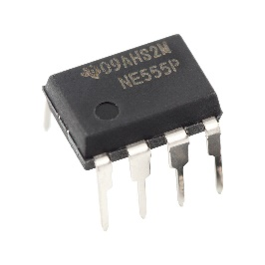

**Attention:**

1. Please dismantle the prewired probe, but make sure the top and bottom positive and negative strips are connected, respectively (as Fig. 6 attached).
2. Capacitor C1 positive and negative

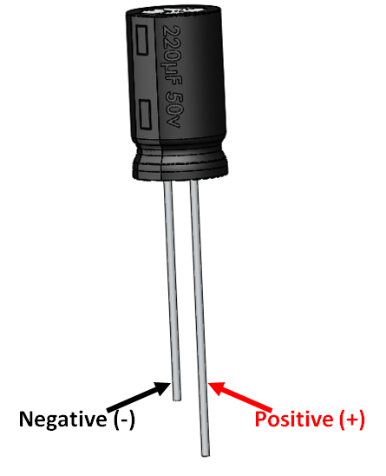

**Select for R2.**

The period T=5.1706 second, the duty cycle D=0.9558.

Please use the equation below to computer the T and D.

Find the correct R2 and make the connections.

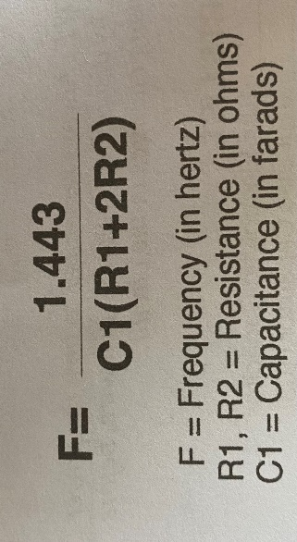



1. **Reaction game**

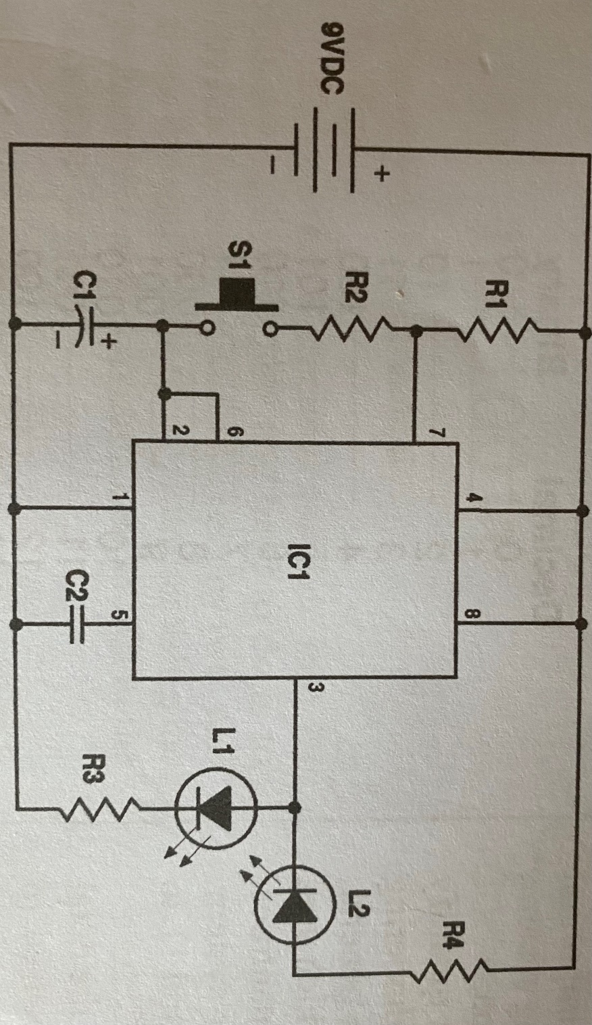

Connect S1 correctly. S1 is the pushbutton switch

Try to release S1 when green LED is ON. If released in time, green LED will remain ON!

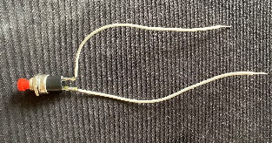

Change R2 into 22KΩ resistor(red,red,orange) which can increase the difficulty, see if you still can catch green LED!

Please demonstrate your result to me in class. Otherwise, submit the screenshot of your circuit connection to canvas (submission portal posted later).